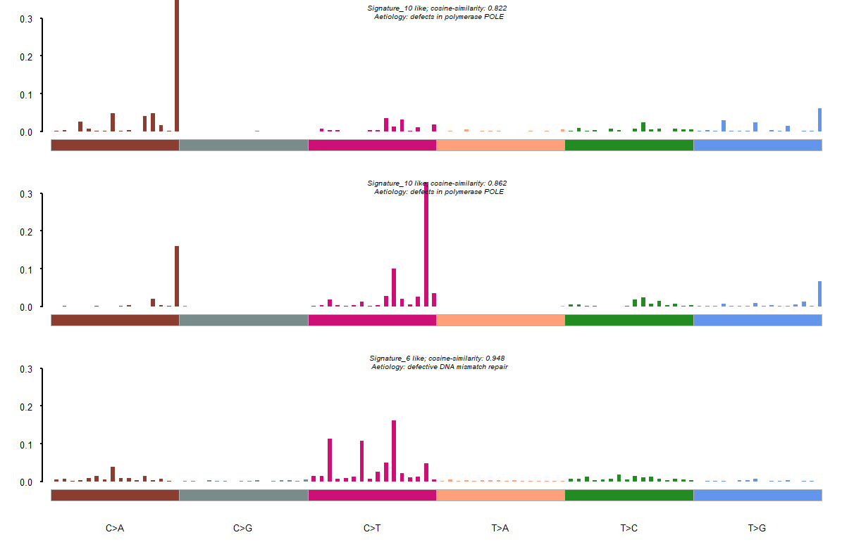COAD

--Found Signature_1 most similar COSMIC Signature_10.

Aetiology: defects in polymerase POLE [cosine-similarity: 0.822]

--Found Signature_2 most similar COSMIC Signature_10.

Aetiology: defects in polymerase POLE [cosine-similarity: 0.862]

--Found Signature_3 most similar COSMIC Signature_6.

Aetiology: defective DNA mismatch repair [cosine-similarity: 0.948]

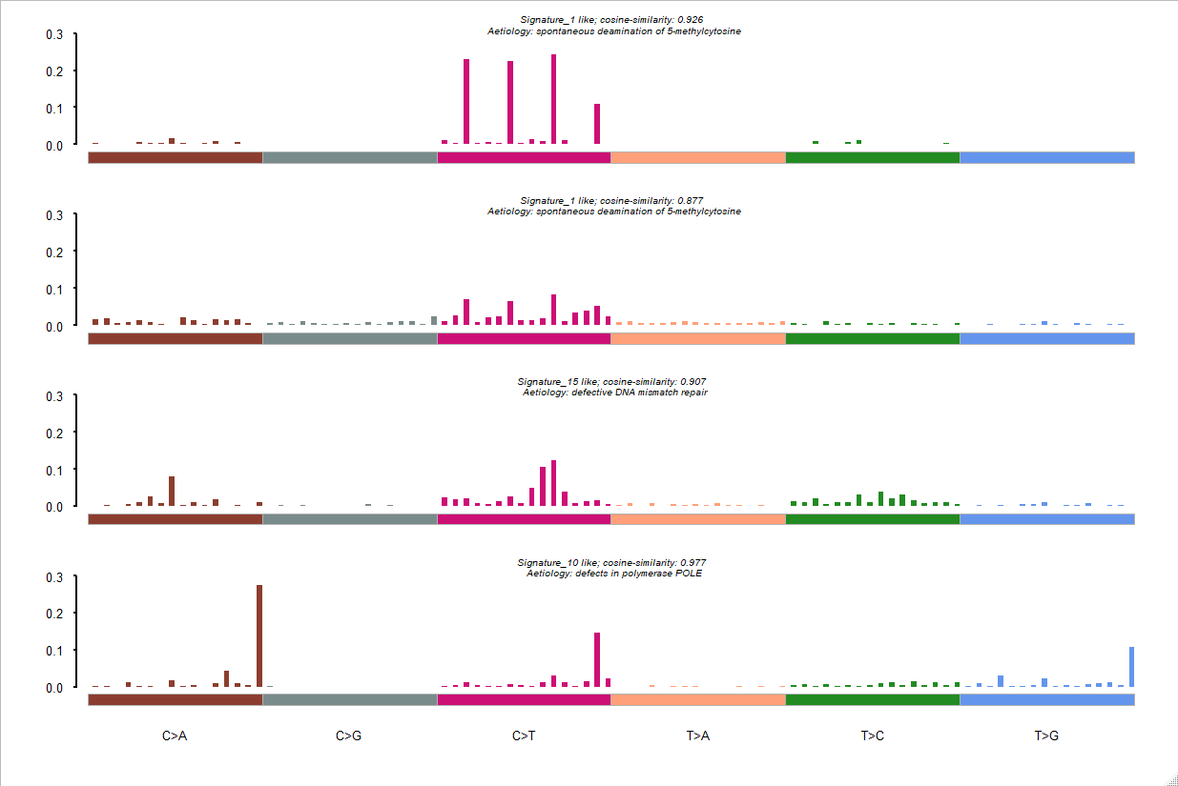

--Found Signature_1 most similar COSMIC Signature_1.

Aetiology: spontaneous deamination of 5-methylcytosine [cosine-similarity: 0.926]

--Found Signature_2 most similar COSMIC Signature_1.

Aetiology: spontaneous deamination of 5-methylcytosine [cosine-similarity: 0.877]

--Found Signature_3 most similar COSMIC Signature_15.

Aetiology: defective DNA mismatch repair [cosine-similarity: 0.907]

--Found Signature_4 most similar COSMIC Signature_10.

Aetiology: defects in polymerase POLE [cosine-similarity: 0.977

**SKCM**

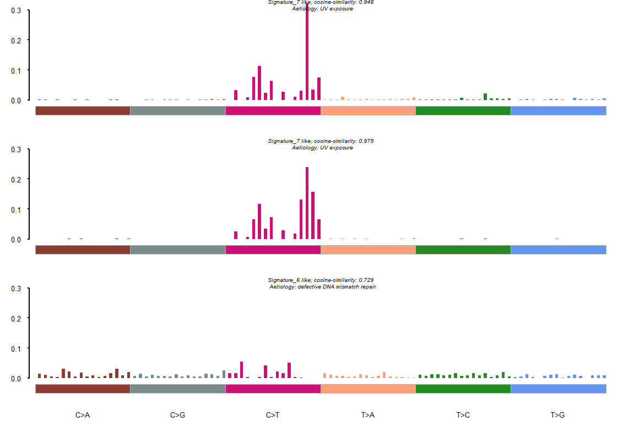

--Found Signature_1 most similar COSMIC Signature_7.

Aetiology: UV exposure [cosine-similarity: 0.948]

--Found Signature_2 most similar COSMIC Signature_7.

Aetiology: UV exposure [cosine-similarity: 0.975]

--Found Signature_3 most similar COSMIC Signature_6.

Aetiology: defective DNA mismatch repair [cosine-similarity: 0.729]

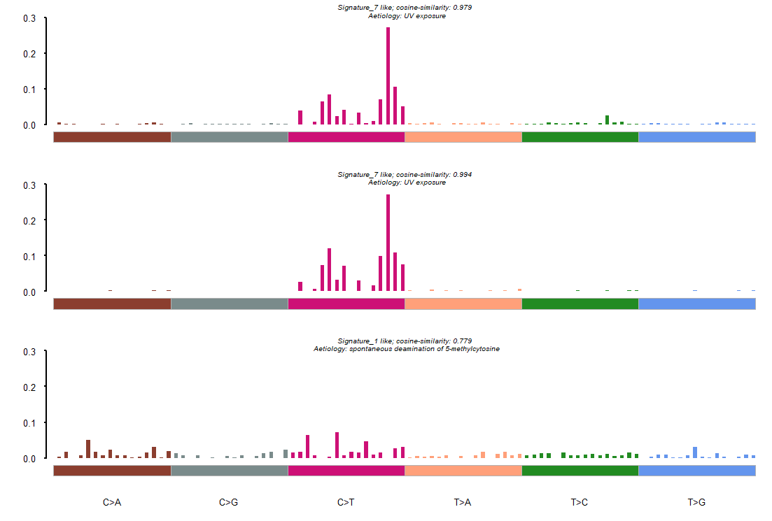

--Found Signature_1 most similar COSMIC Signature_7.

Aetiology: UV exposure [cosine-similarity: 0.979]

--Found Signature_2 most similar COSMIC Signature_7.

Aetiology: UV exposure [cosine-similarity: 0.994]

--Found Signature_3 most similar COSMIC Signature_1.

Aetiology: spontaneous deamination of 5-methylcytosine [cosine-similarity: 0.779]



--Found Signature_1 most similar COSMIC Signature_7.

Aetiology: UV exposure [cosine-similarity: 0.99]

--Found Signature_2 most similar COSMIC Signature_7.

Aetiology: UV exposure [cosine-similarity: 0.99]

--Found Signature_3 most similar COSMIC Signature_5.

Aetiology: Unknown [cosine-similarity: 0.753]

**LUAD**

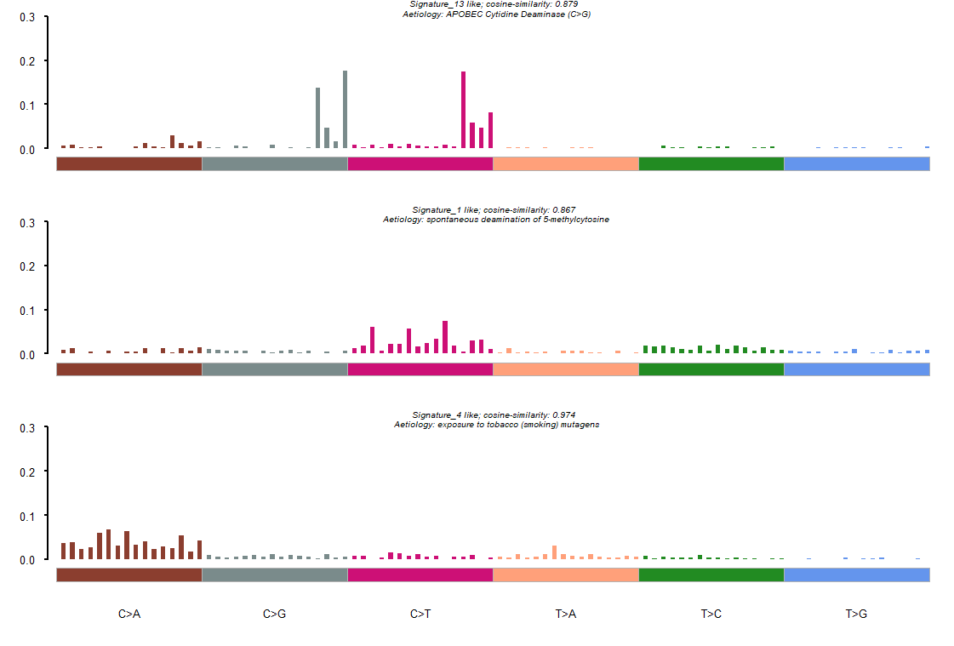

--Found Signature_1 most similar COSMIC Signature_13.

Aetiology: APOBEC Cytidine Deaminase (C>G) [cosine-similarity: 0.879]

--Found Signature_2 most similar COSMIC Signature_1.

Aetiology: spontaneous deamination of 5-methylcytosine [cosine-similarity: 0.867]

--Found Signature_3 most similar COSMIC Signature_4.

Aetiology: exposure to tobacco (smoking) mutagens [cosine-similarity: 0.974]

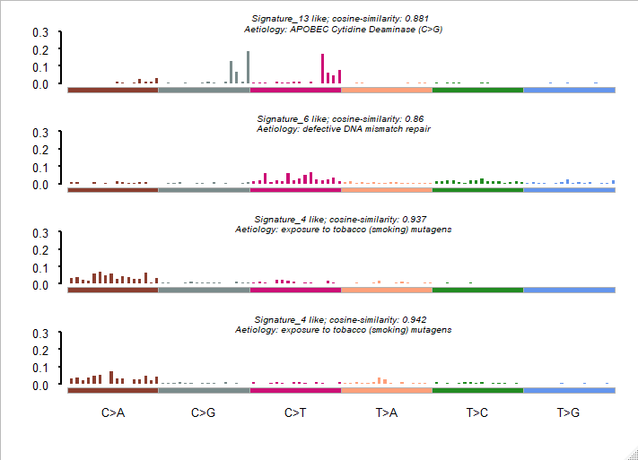

--Found Signature_1 most similar COSMIC Signature_13.

Aetiology: UV exposure [cosine-similarity: 0.891]

--Found Signature_2 most similar COSMIC Signature_6.

Aetiology: UV exposure [cosine-similarity: 0.86]

--Found Signature_3 most similar COSMIC Signature_4.

Aetiology: UV exposure [cosine-similarity: 0.937]

--Found Signature_4 most similar COSMIC Signature_4.

Aetiology: defective DNA mismatch repair [cosine-similarity: 0.942]

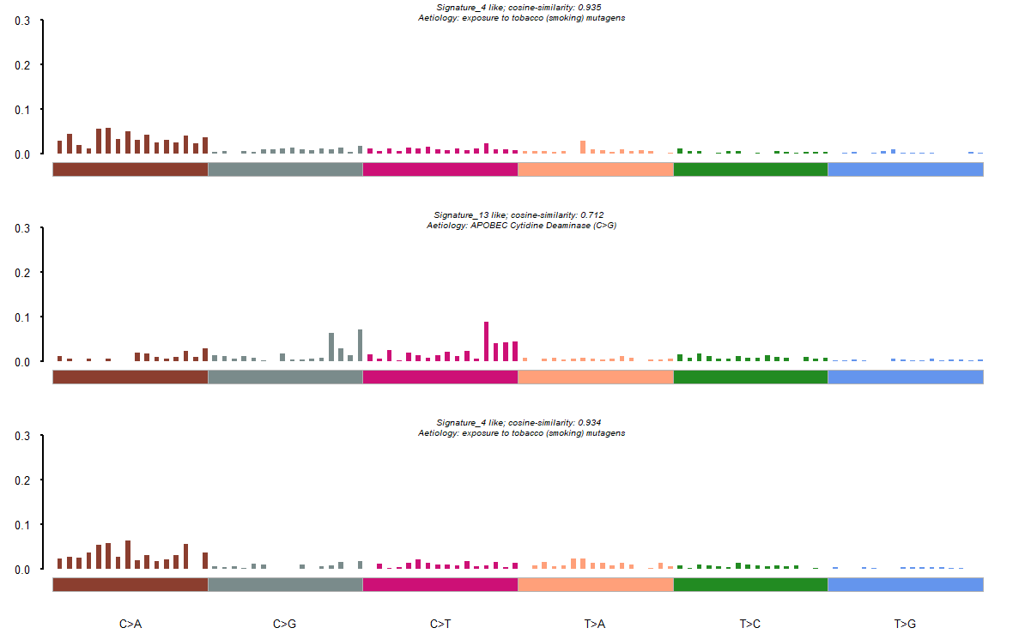

--Found Signature_1 most similar COSMIC Signature_4.

Aetiology: exposure to tobacco (smoking) mutagens [cosine-similarity: 0.935]

--Found Signature_2 most similar COSMIC Signature_13.

Aetiology: APOBEC Cytidine Deaminase (C>G) [cosine-similarity: 0.712]

--Found Signature_3 most similar COSMIC Signature_4.

Aetiology: exposure to tobacco (smoking) mutagens [cosine-similarity: 0.934]

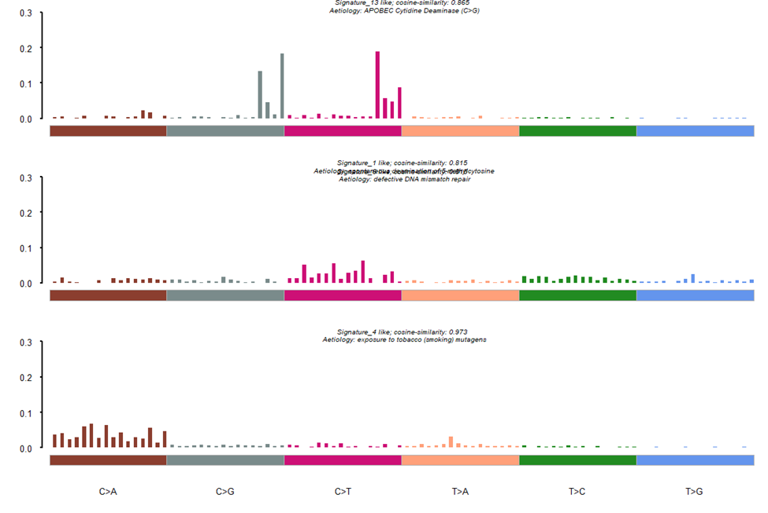

--Found Signature_1 most similar COSMIC Signature_13.

Aetiology: APOBEC Cytidine Deaminase (C>G) [cosine-similarity: 0.865]

--Found Signature_2 most similar COSMIC Signature_1Signature_6.

Aetiology: spontaneous deamination of 5-methylcytosine [cosine-similarity: 0.815]

Aetiology: defective DNA mismatch repair [cosine-similarity: 0.815]

--Found Signature_3 most similar COSMIC Signature_4.

Aetiology: exposure to tobacco (smoking) mutagens [cosine-similarity: 0.973]

**LUSC**

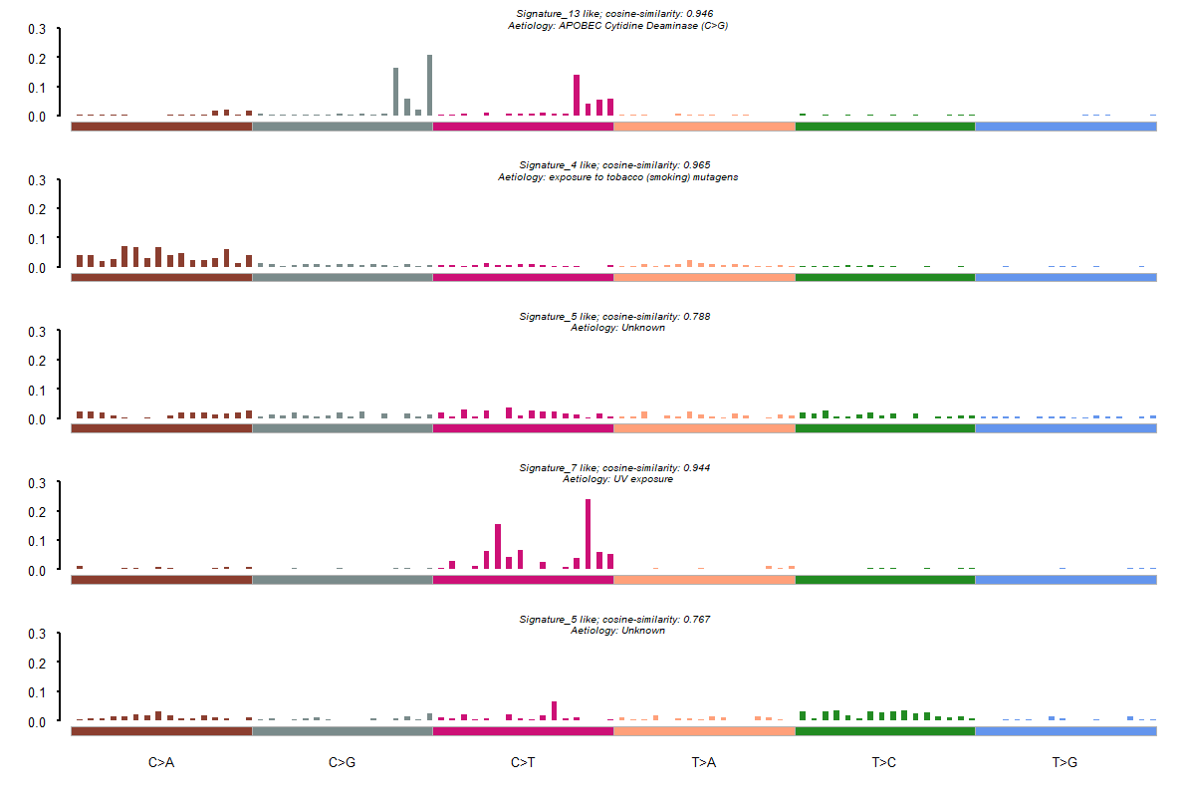

--Found Signature_1 most similar COSMIC Signature_13.

Aetiology: APOBEC Cytidine Deaminase (C>G) [cosine-similarity: 0.946]

--Found Signature_2 most similar COSMIC Signature_4.

Aetiology: exposure to tobacco (smoking) mutagens [cosine-similarity: 0.965]

--Found Signature_3 most similar COSMIC Signature_5.

Aetiology: Unknown [cosine-similarity: 0.788]

--Found Signature_4 most similar COSMIC Signature_7.

Aetiology: UV exposure [cosine-similarity: 0.944]

--Found Signature_5 most similar COSMIC Signature_5.

Aetiology: Unknown [cosine-similarity: 0.767]

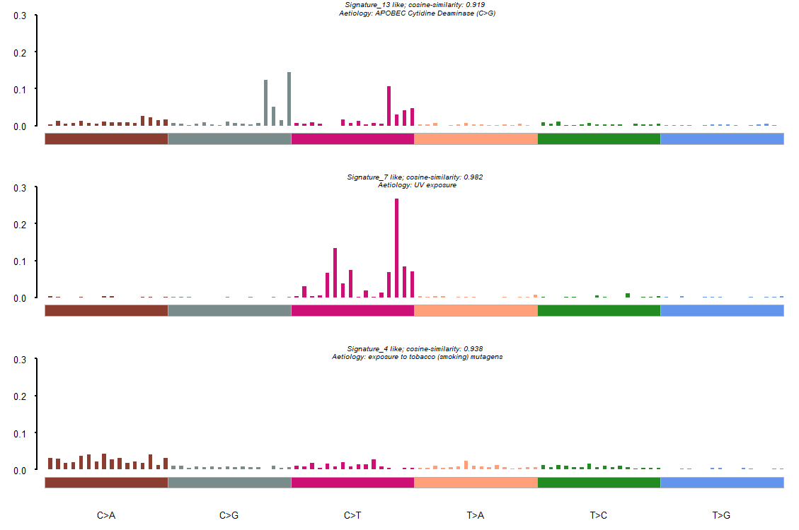

--Found Signature_1 most similar COSMIC Signature_13.

Aetiology: APOBEC Cytidine Deaminase (C>G) [cosine-similarity: 0.919]

--Found Signature_2 most similar COSMIC Signature_7.

Aetiology: UV exposure [cosine-similarity: 0.982]

--Found Signature_3 most similar COSMIC Signature_4.

Aetiology: exposure to tobacco (smoking) mutagens [cosine-similarity: 0.938]

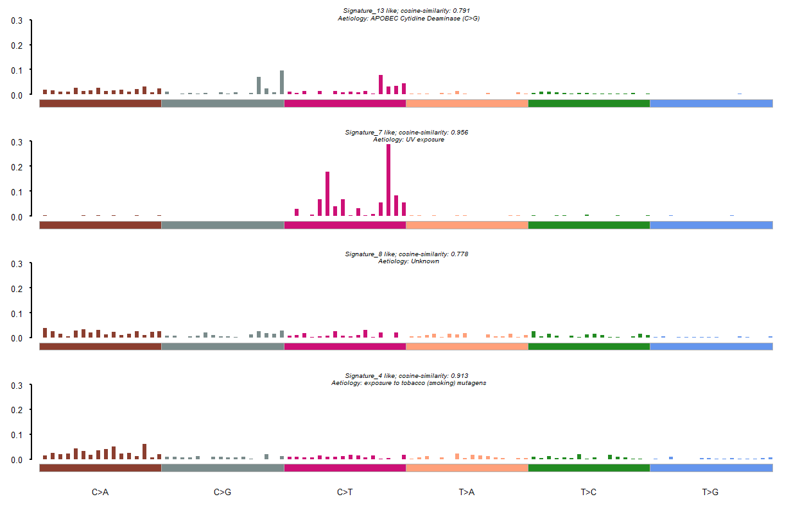

--Found Signature_1 most similar COSMIC Signature_13.

Aetiology: APOBEC Cytidine Deaminase (C>G) [cosine-similarity: 0.791]

--Found Signature_2 most similar COSMIC Signature_7.

Aetiology: UV exposure [cosine-similarity: 0.956]

--Found Signature_3 most similar COSMIC Signature_8.

Aetiology: Unknown [cosine-similarity: 0.778]

--Found Signature_4 most similar COSMIC Signature_4.

Aetiology: exposure to tobacco (smoking) mutagens [cosine-similarity: 0.913]

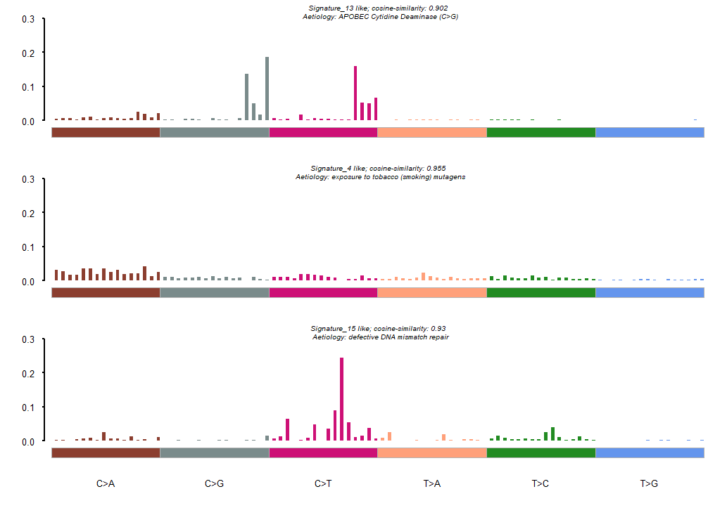

--Found Signature_1 most similar COSMIC Signature_13.

Aetiology: APOBEC Cytidine Deaminase (C>G) [cosine-similarity: 0.902]

--Found Signature_2 most similar COSMIC Signature_4.

Aetiology: exposure to tobacco (smoking) mutagens [cosine-similarity: 0.955]

--Found Signature_3 most similar COSMIC Signature_15.

Aetiology: defective DNA mismatch repair [cosine-similarity: 0.93]